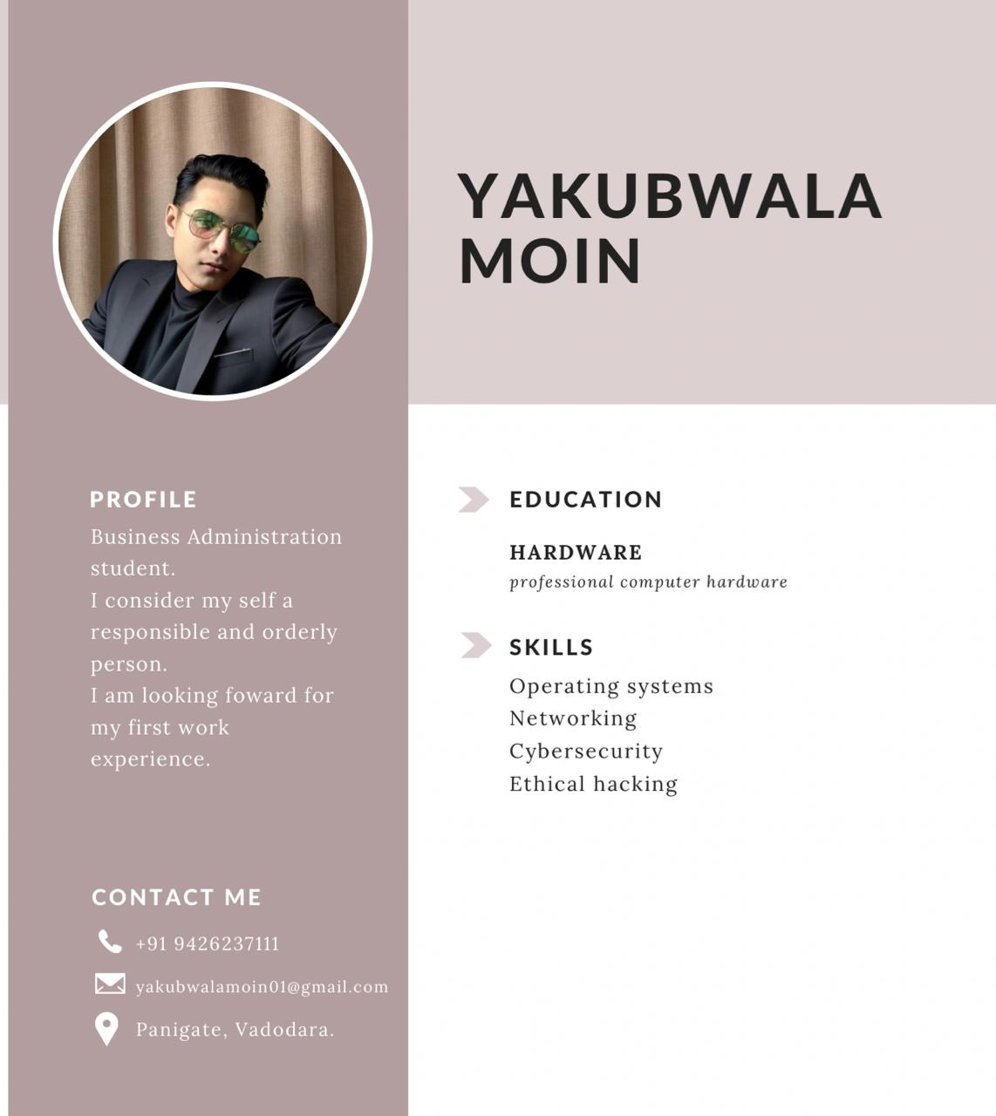

Linkedin Linke

<https://www.linkedin.com/in/moin-yakubwala-4a570533a/>